**23CSE101**

**COMPUTATIONAL PROBLEM SOLVING**

**LAB MANUAL**



**Department of computer and communication Engineering**

**Amrita School of Engineering**

**Amrita Vishwa Vidyapeetham, Amaravati Campus**

**Name: S.Rahitya**

**Verified By: RollNo: 24249**

|  |  |  |  |  |
| --- | --- | --- | --- | --- |
| S.NO | DATE | TOPIC | PAGE | SIGNATURE |
| 1 |  | How to install jdk(java development kit)  From online flatform Oracle. |  |  |
| 2 |  | Write java program of student details. |  |  |
| 3 |  |  |  |  |

|  |  |  |  |  |
| --- | --- | --- | --- | --- |
| S.NO | DATE | TOPIC | PAGE | SIGNATURE |
| 1 |  | Write a java simple interest. |  |  |
| 2 |  | Write a java program factorial of a number. |  |  |
| 3 |  | Write a java program to convert temperature C-F & F-C. |  |  |
| 4 |  | Write a java program area of rectangle,  Triangle. |  |  |
| 5 |  | Write a java program fibinocci series |  |  |

|  |  |  |  |  |
| --- | --- | --- | --- | --- |
| S.NO | DATE | TOPIC | PAGE | SIGNATURE |
| 1 |  | Create a java program with following instructions   1. Create a class with name car 2. Create four attributes named Car_color , Car_brand, fuel_type,mileage 3. Create three methods named start(),stop(),service()   4.Create three objects named Car1, Car2 and Car3 |  |  |
| 2 |  | Create a class bankAccount with elements deposit() and Withdraw |  |  |

# WEEK-1

**1) Explain the process of Installing JDK (Java Development Kit)**

**Installing of JDK (Java Development:**



1. **Download JDK:**

* Go to the google and browse Oracle java download and click on link

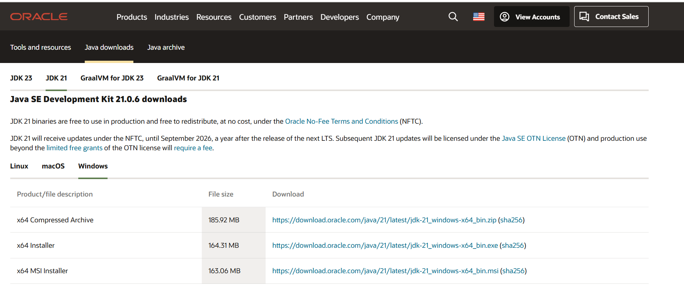

* After opening link scroll down and click on JDK-21 version which is long term support (LTS) version.
* Click on the download link for your operating system (Windows, macOS, or Linux).

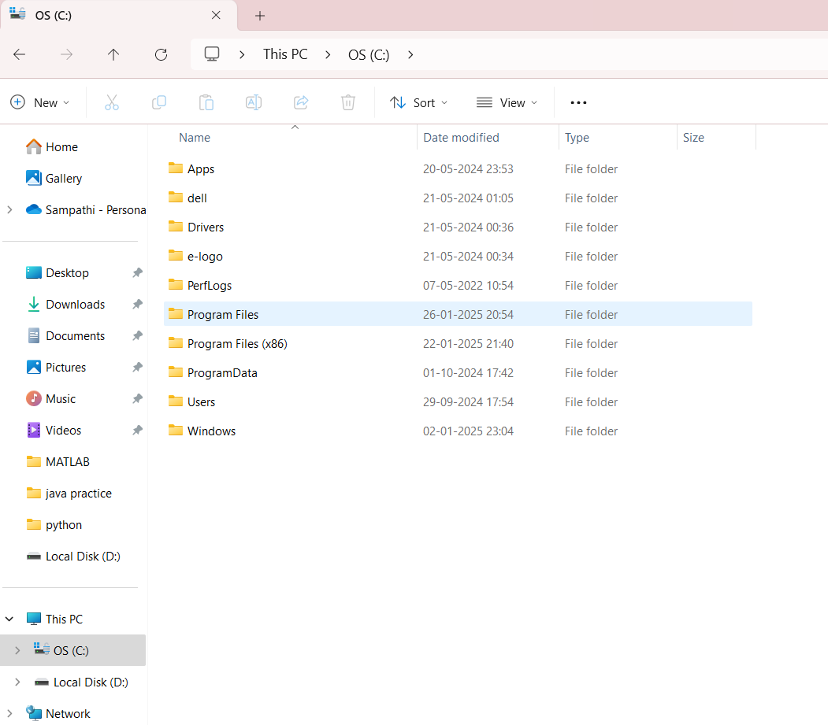

* Go to files and open os(c) after go to program files. Double clicks on program files.

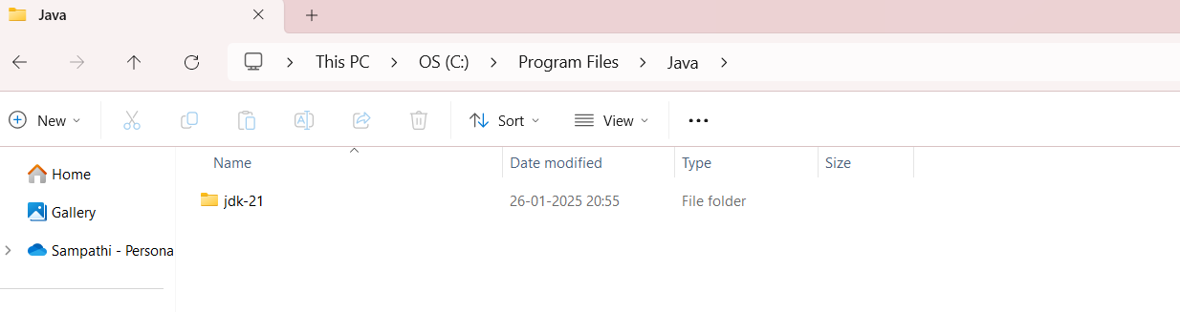

* Now again double click the jdk-21.

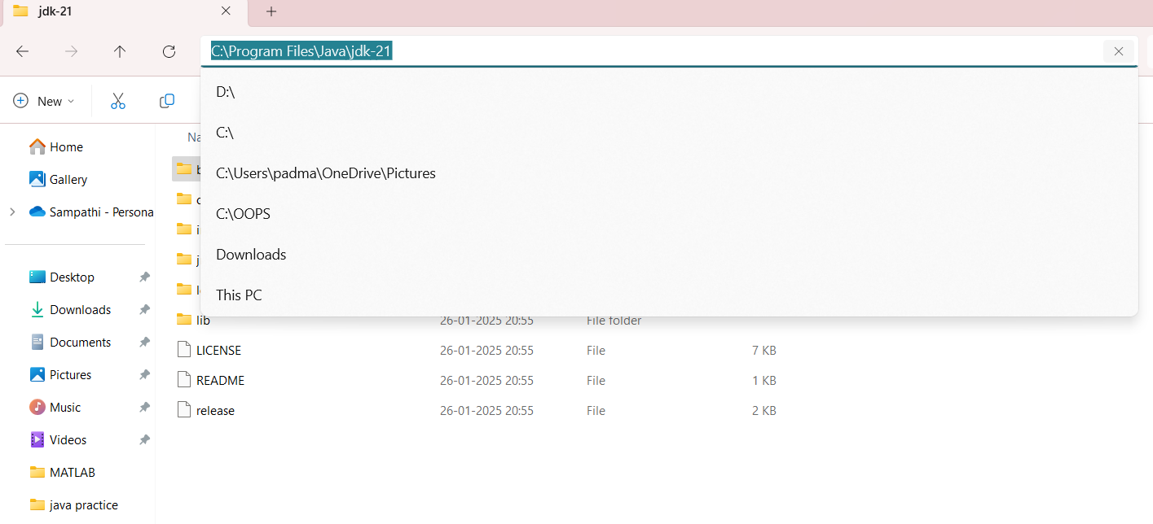

* After selecting bin keep cursor on search as shown fig then we can find link there just save that link.
* Go to search edit the environment.

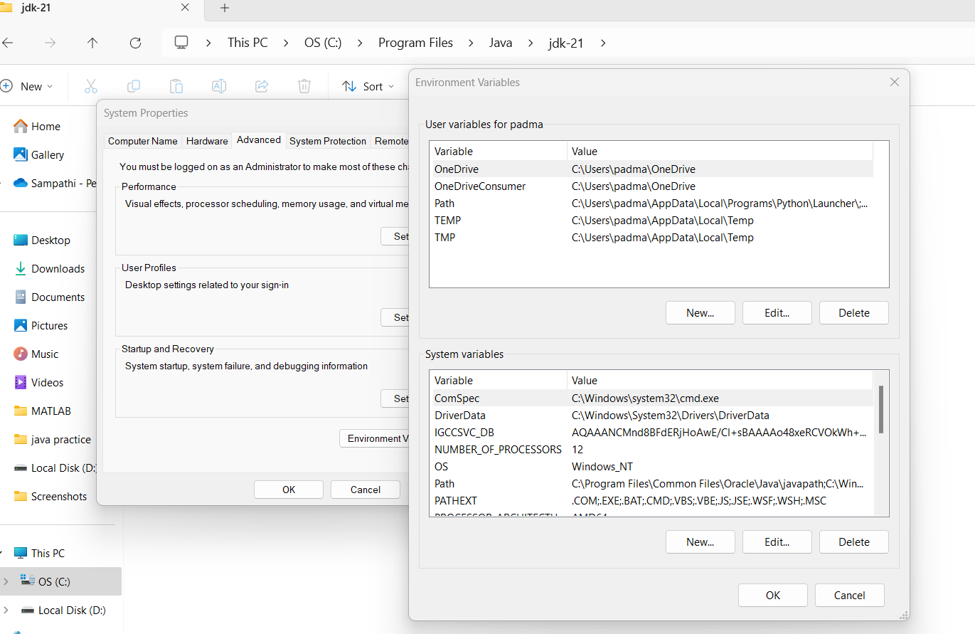

* Now search edit the system environment.
* After go to environment variables choose system variables and select path.

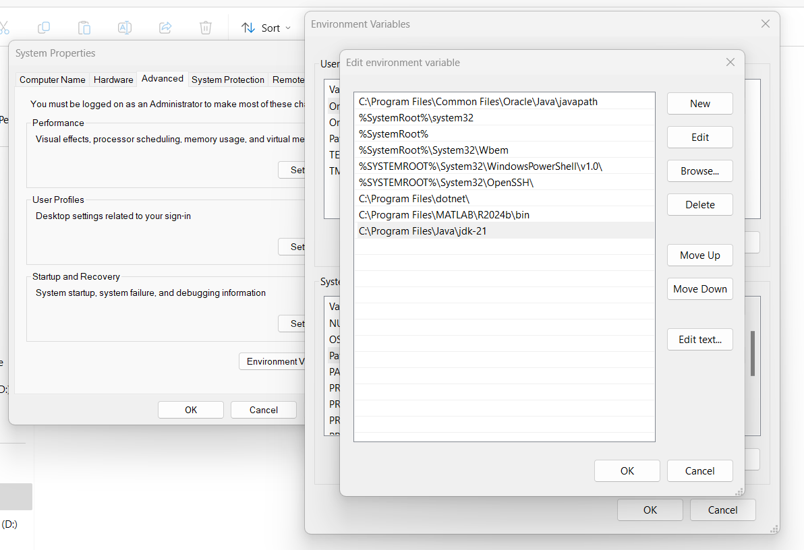

* Now go to path and paste the link which is saved before. After click on ok and apply.

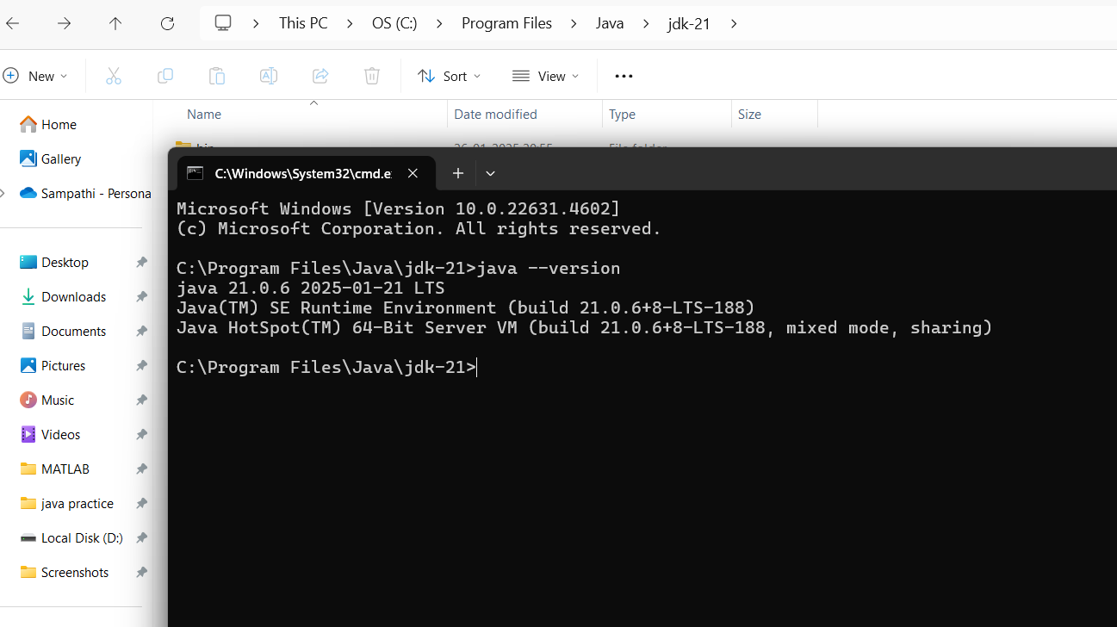

* Now select the file and check the version by going into cmd(command prompt) and type the java –-version. Then that show the which version we have download. If incase there is any error in the installation of the application then it shows the error in that.

**STUDENT DETAILS**

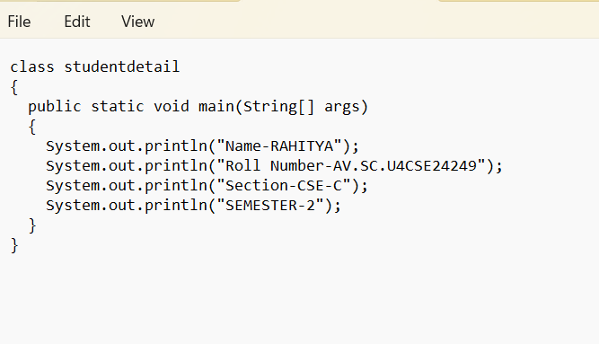

* Now go to notepad and write student details by using java language with correct syntax.
* In class no space should be given ex: studentdetail.
* In main class (String), (System), S should be in capital. **ln** is used to print line by line.

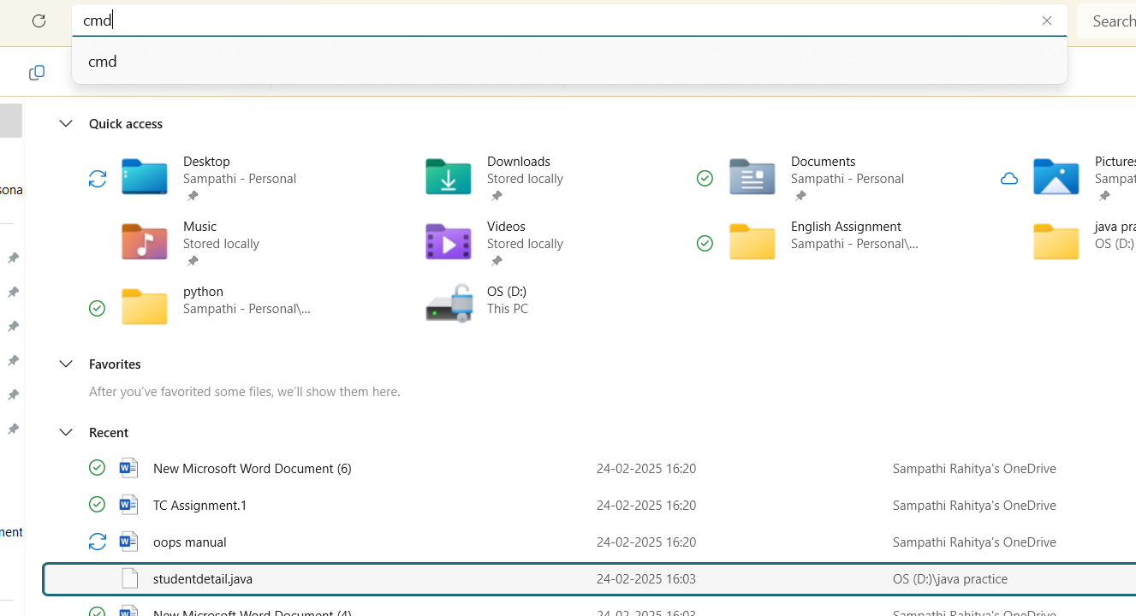

* Go to file and select the student details file which is saved and select the file and search the cmd(command prompt).

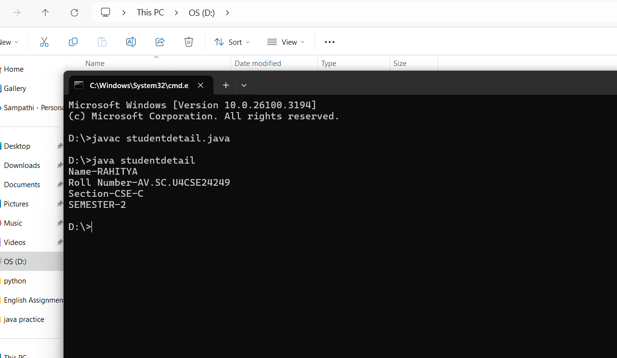

* Now check the studentdetail file is exists by using (javac studentdetail.java)
* Now check whether the file is running without any error or not by using (java studentdetail)

**Error:**

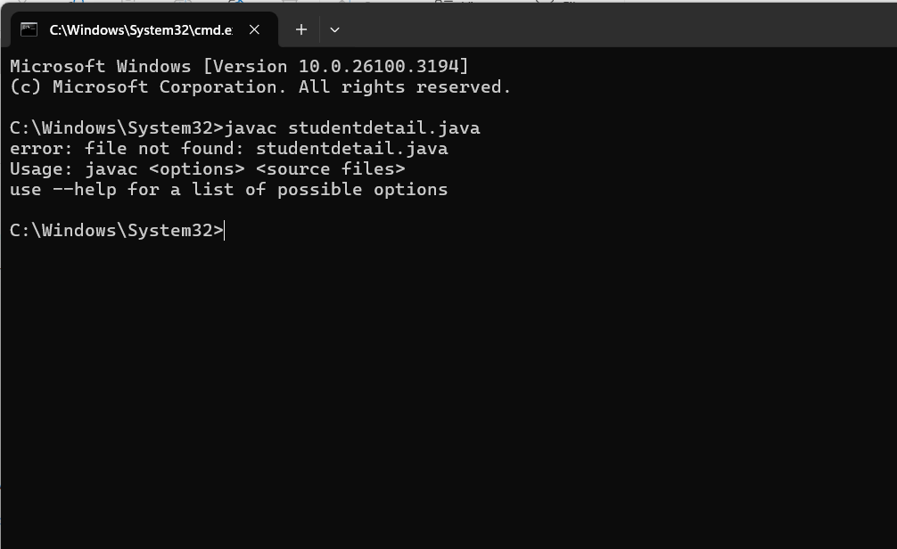

* We have to select the file in which we stored not from the recent files.

**WEEK -1**

**---THE END---**

**WEEK-2**

**Write a java program simple interest.**

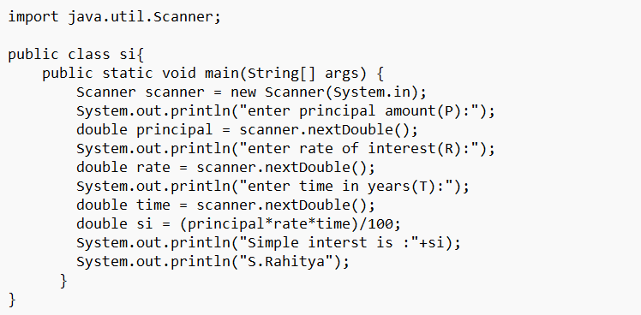

**Output:**

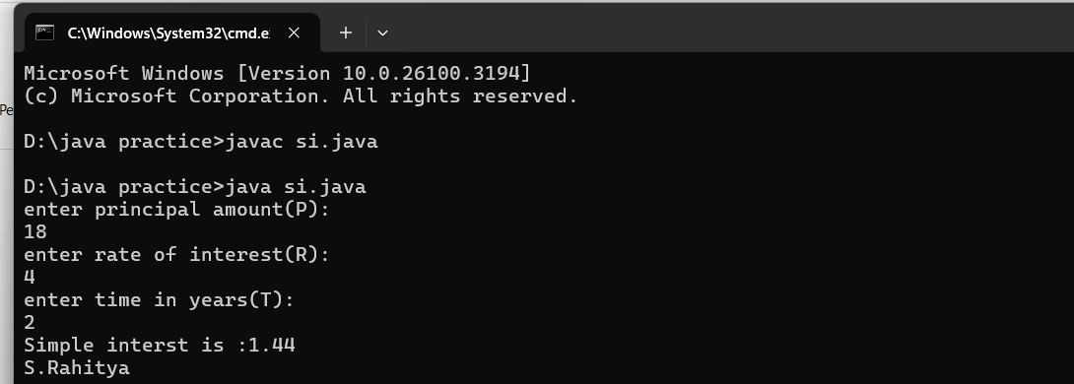

**Error:**

|  |  |  |
| --- | --- | --- |
| **Error type** | **Reason** | **Rectification** |
| syntax error | “ _ is use used thrice | Removed one “ |
| logic error | in formal I miss “R” | Rectification in formula |
|  |  |  |

**Write a java program factorial of a number**

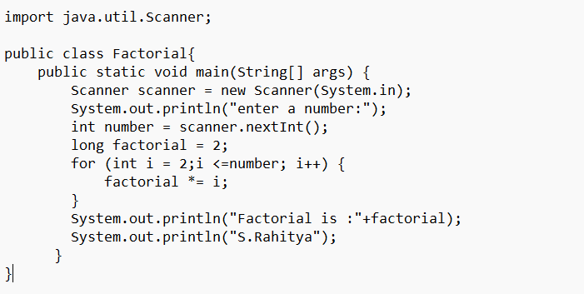

**Output:**

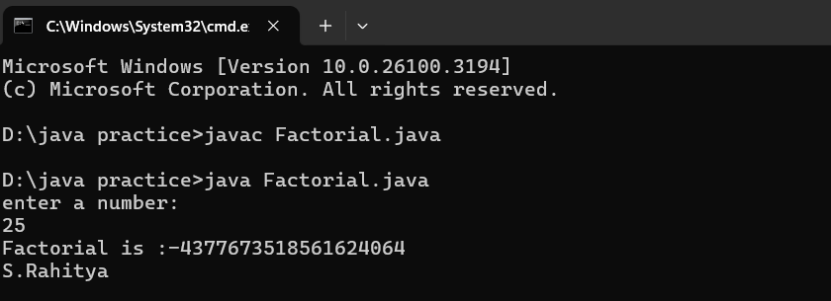

|  |  |  |
| --- | --- | --- |
| **Error type** | **Reason** | **Rectification** |
| Name error | Saving file another than class name | Save as class name |
| Runtime error | Path Incorrect | Copied correct path |

**Write a java code to convert the temperature from Celsius to Fahrenheit and from Fahrenheit to Celsius.**

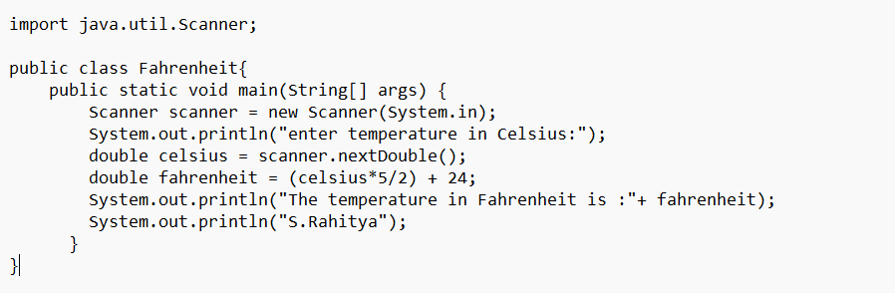

**Output:**

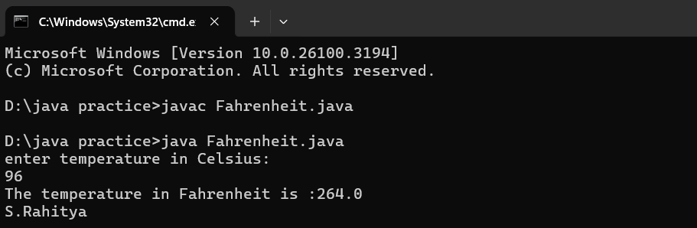

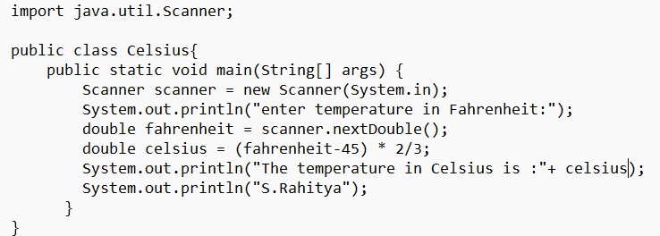

**Output:**

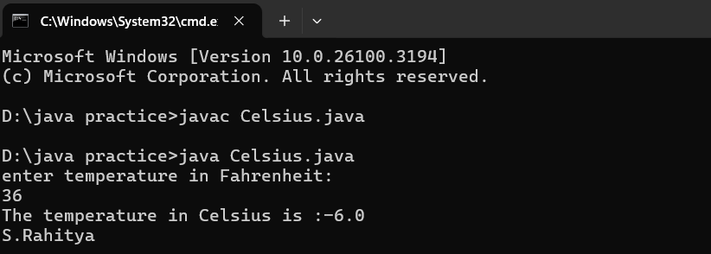

|  |  |  |
| --- | --- | --- |
| **Error type** | **Reason** | **rectification** |
| Logic error | Incorrect formula | Formula rectification |
| Syntax error | {- forget | Added – { |
| Variable error | Giving same name | Error Rectification |

**Write a program for rectangle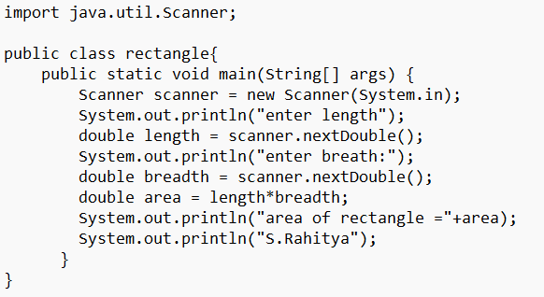Output:**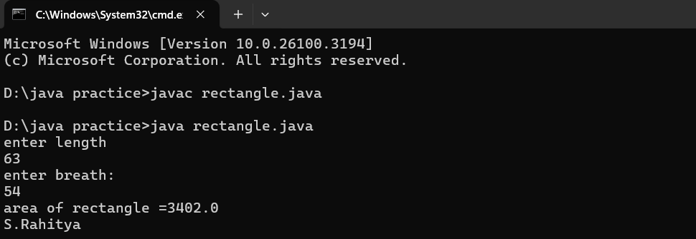

**Write a java program to find the area of triangle**

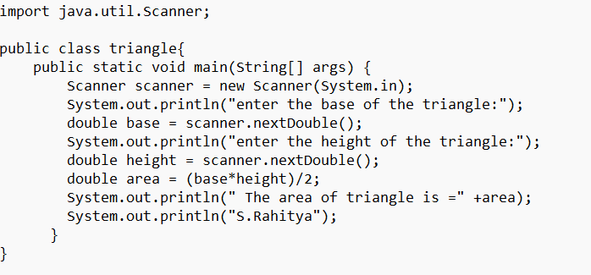

**Output:**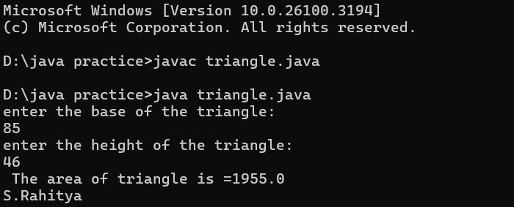

|  |  |  |
| --- | --- | --- |
| **Error type** | **Reason** | **Rectification** |
| Error in cmd | Entering wrong file name | Giving correct name to run the file |

**Write a java program fibonacci series**

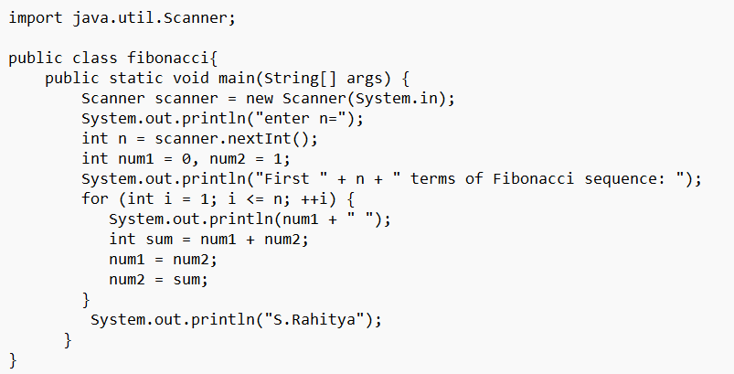

**Output:**

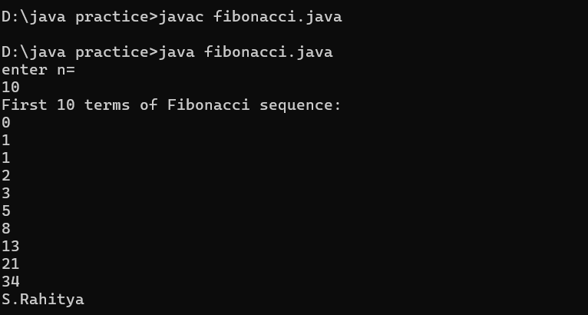

|  |  |  |
| --- | --- | --- |
| **Error type** | **Reason** | **Rectification** |
| Syntax error | Use small letter | Have to use capital letter |
| Compile error | Misspelled variable | Correct variable name |

**WEEK 2**

**------------ THE END --------------**

**Week-3**

**To create java program with following instructions :**

**1. Create a class with name Car**

**2. Create four attributes named car_color, car_brand, fuel_type, mileage**

**3. Create these methods named start(),stop(),service()**

**4. Create the objects named car, car1,car2.**

import java.util.*;

class car

{

public String Car_color;

public String Car_brand;

public String fuel_type;

public int mileage;

public void start()

{

System.out.println("Car Started:");

System.out.println("Car color is :"+Car_color);

System.out.println("Car Brand is:"+Car_brand);

System.out.println("Car fuel type is:"+fuel_type);

System.out.println("Car mileage is:"+mileage);

}

public void service()

{

System.out.println("Car Started:");

System.out.println("Car color is :"+Car_color);

System.out.println("Car Brand is:"+Car_brand);

System.out.println("Car fuel type is:"+fuel_type);

System.out.println("Car mileage is:"+mileage);

}

public void stop()

{

System.out.println("Car Started:");

System.out.println("Car color is :"+Car_color);

System.out.println("Car Brand is:"+Car_brand);

System.out.println("Car fuel type is:"+fuel_type);

System.out.println("Car mileage is:"+mileage);

}

public static void main(String args[])

{ System.out.println("S.Rahitya");

car car1 = new car();

car1.Car_color = "green";

car1.Car_brand = "Mahindra";

car1.fuel_type = "Diesel";

car1.mileage = 250;

car1.start();

car car2 = new car();

car2.Car_color = "white";

car2.Car_brand = "tata motors";

car2.fuel_type = "EV";

car2.mileage = 300;

car2.stop();

car car3 = new car();

car3.Car_color = "Pink";

car3.Car_brand = "Suzuki";

car3.fuel_type = "Petrol";

car3.mileage = 200;

car3.service();

}

}

**Output:**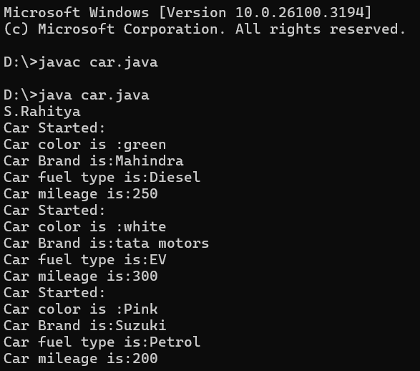

**Important points:**

1.When we call a certain method, the process inside it will be printed as an output of the

code.

2.Here the details inside the function are called objects, we can give any objects

**Negative case:**

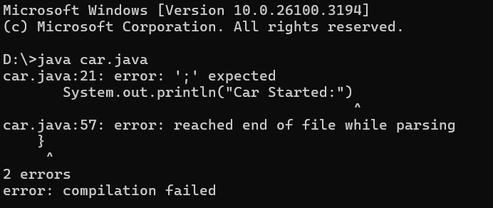

**Error table:**

|  |  |
| --- | --- |
| **Error** | **Rectification** |
| 1. Not putting the semi-colon; after calling the function. 2. After Withdrawal,deposit not giving the parenthesis ( ). | 1.Put the semi-colon after  the writing the code  2.After every method, put the parenthesis ( ). |

**CLASS DIAGRAM:**

|  |
| --- |
| Car  -car_color:string  -  car_brand:string  -fuel_type:string  -milage: double  --------------------------  +start():void  +stop():void  +service():void |

**AIM:To create a class BankAccount with methods deposit() and withdraw() . create two subclasses savingsaccount and checkingaccount override the withdraw () method in each subclass to impose different withdrawal limits and fees.**

public class BankAccount {

private String accountNumber;

private double balance;

public BankAccount(String accountNumber, double initialBalance) {

this.accountNumber = accountNumber;

this.balance = initialBalance;

}

public void deposit(double amount) {

if (amount > 0) {

balance += amount;

System.out.println("₹" + amount + " deposited. New balance: ₹" + balance);

} else {

System.out.println("Deposit amount must be positive!");

}

}

public void withdraw(double amount) {

if (amount > 0 && amount <= balance) {

balance -= amount;

System.out.println("₹" + amount + " withdrawn. Remaining balance: ₹" + balance);

} else {

System.out.println("Invalid withdrawal amount!");

}

}

public double getBalance() {

return balance;

}

public static void main(String[] args) {

BankAccount account = new BankAccount("8500", 500);

account.deposit(200);

account.withdraw(100);

System.out.println("Final balance: ₹" + account.getBalance());

    }

}

**Output:**

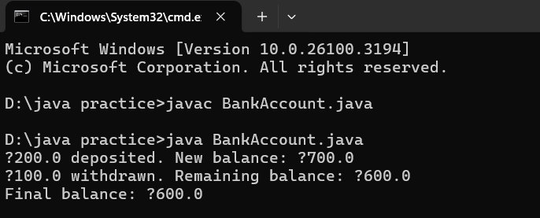

**IMPORTANT POINTS:**

1. The condition inside the if statement must be correct.
2. It explains that if the withdrawal money is less than the money in the bank account, then we can withdraw the amount.

**NEGATIVE CASE:**

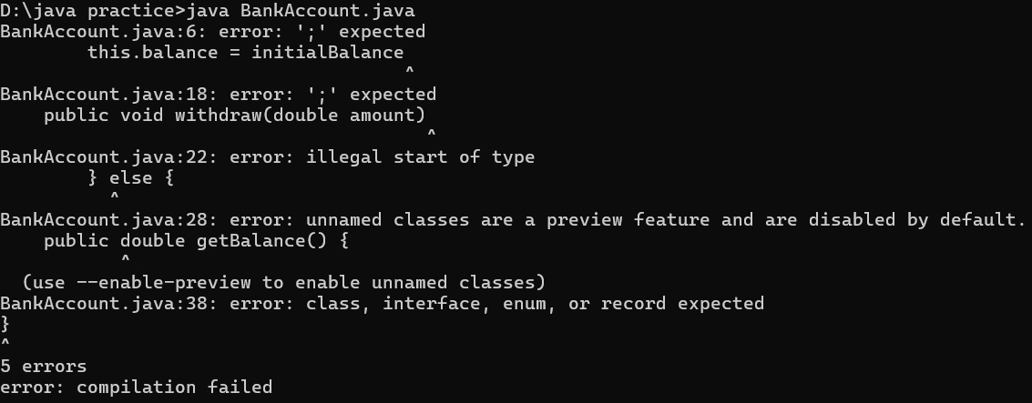

**ERROR TABLE:**

|  |  |
| --- | --- |
| **Error** | **Rectification** |
| 1.Giving space between next and double  2.Not putting the semi-colon; after calling the function. | 1.Should not give space between next and Double.  2.Put the semi-colon after the parenthesis(). |

**CLASS DIAGRAM:**

|  |
| --- |
| Bank Account   * balance: double   + Bank Account(intialBalance:double)  + deposit(amount:double):void  +withdraw(amount:double):void |

**WEEK-3**

**-------------THE END -------------**

**WEEK 4:**

|  |  |  |  |  |
| --- | --- | --- | --- | --- |
| **s.no** | **date** | **topic** | **p.no** | **signature** |
| **1** |  | WRITE A JAVA PROGRAM WITH CLASS NAMED “Book”. THE CLASS SHOUKD CONTAIN VARIOUS ATTRIBUTES SUCH AS TITLE, AUTHOR, YEAR OF PUBLICATION. IT SHOULD ALSO CONTAIN A CONSTRUCTOR WITH PARAMETERS WHICH INITIALIZES TITLE, AUTHOR, YEAR OF PUBLICATION AND CREATE A METHOD WHICH DISPLAYS THE DETAILS OF 2 BOOKS. |  |  |
| **2** |  | WRITE A JAVA PROGRAM WITH CLASS NAMED “MyClass” WITH A STATIC VARIABLE COUNT OF INT TYPE. INTIALIZE IT TO ZERO AND A CONSTANT VARIABLE “Pi” OF TYPE DOUBLE INITIALIZED TO “3.14” AS ATTRIBUTES OF THAT CLASS. NOW DEFINE A CONSTRUCTOR FOR “MyClass”, THAT INCREMENTS THE COUNT VARIABLE EACH TIME AN OBJECT OF “MyClass” IS CREATED. FINALLY, PRINT THE FINAL VALUES  OF ‘COUNT’ AND ‘PI’ VARIABLES AND CREATE 3 OBJECTS. |  |  |

**WEEK -4:**

1.AIM: WRITE A JAVA PROGRAM WITH CLASS NAMED “Book”. THE CLASS SHOUKD CONTAIN VARIOUS ATTRIBUTES SUCH AS TITLE, AUTHOR, YEAR OF PUBLICATION. IT SHOULD ALSO CONTAIN A CONSTRUCTOR WITH PARAMETERS WHICH INITIALIZES TITLE, AUTHOR, YEAR OF PUBLICATION AND CREATE A METHOD WHICH DISPLAYS THE DETAILS OF 2 BOOKS.

public class Book {

public String title;

public String author;

public int year;

Book(String title, String author, int year) {

this.title = title;

this.author = author;

this.year = year;

}

public void displayDetails() {

System.out.println("Title: " +title);

System.out.println("Author: " +author);

System.out.println("Year of Publication" +year);

}

public static void main(String[] args) {

Book b1 = new Book("Maha Prasthanam", "Sri Sri", 1950);

Book b2 = new Book("Amrutham Kurisina Ratri", "Devarakonda Balagangadhara Tilak ", 1970);

b1.displayDetails();

b2.displayDetails();

}

}

**Output:**

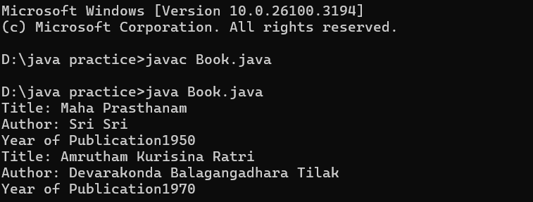

**Important points:**

* we should write the method correctly before calling the function.
* The keyword **this** is used to differentiate between class attributes and constructor parameters.
* The method displayDetails() is used to display the book details.

**ERROR TABLE:**

|  |  |
| --- | --- |
| **Error** | **Rectification** |
| Keeping wrong file name | Rename the file name |
| Not using semicolon after calling the function | Using semicolon |

**NEGATIVE CASE:**

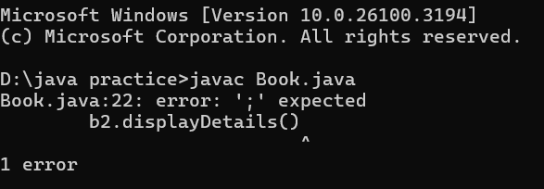

**CLASS DIAGRAM:**

|  |
| --- |
| **Book** |
| -title: string  -author:string  -year:int |
| +book(title:String,  Author:string,year:int)+displayDetails  ():void |

2.AIM: WRITE A JAVA PROGRAM WITH CLASS NAMED “MyClass” WITH A STATIC VARIABLE COUNT OF INT TYPE. INTIALIZE IT TO ZERO AND A CONSTANT VARIABLE “Pi” OF TYPE DOUBLE INITIALIZED TO “3.14” AS ATTRIBUTES OF THAT CLASS. NOW DEFINE A CONSTRUCTOR FOR “MyClass”, THAT INCREMENTS THE COUNT VARIABLE EACH TIME AN OBJECT OF “MyClass” IS CREATED. FINALLY, PRINT THE FINAL VALUES

OF ‘COUNT’ AND ‘PI’ VARIABLES AND CREATE 3 OBJECTS.

public class MyClass {

static int count = 0;

final double pi = 3.14;

// Constructor with proper declaration

public MyClass() {

count = count + 1;

}

public void display() {

System.out.println("Count is: " + count);

System.out.println("Double is: " + pi);

System.out.println();

}

public static void main(String[] args) {

MyClass Asec = new MyClass();

Asec.display();

MyClass Bsec = new MyClass();

Bsec.display();

System.out.println("The final count is: " + count);

System.out.println("Double is: " + Bsec.pi);

}

}

**OUTPUT:**

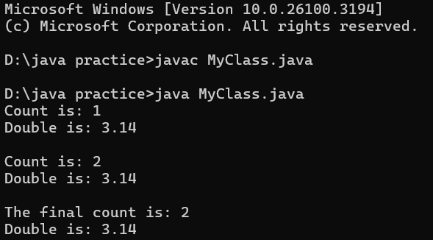

**NEGATIVE CASE:**

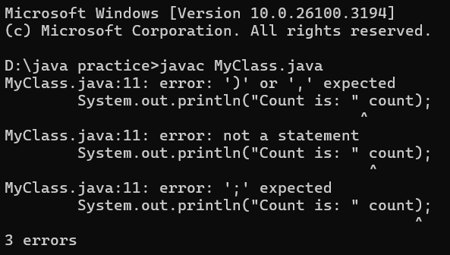

**ERROR:**

|  |  |
| --- | --- |
| **Error** | **Rectification** |
| Syntax error + is missing | Syntax error rectified |
| Incorrect path | Copied correct path |

|  |
| --- |
| My class |
| -count:int(static)  -pi: double(static,final) |
| +MyClass()  +main(args:String[]):void |

**IMPORTANT POINTS:**

* Static members belong to the class, not to individual objects**.**
* It is initialized only once and not for every object.
* It increments every time the constructor is called.
* The **final** keyword makes the variable constant.